3. Launch minikube cluster and execute the commands to test the pod, container with the kubectl commands

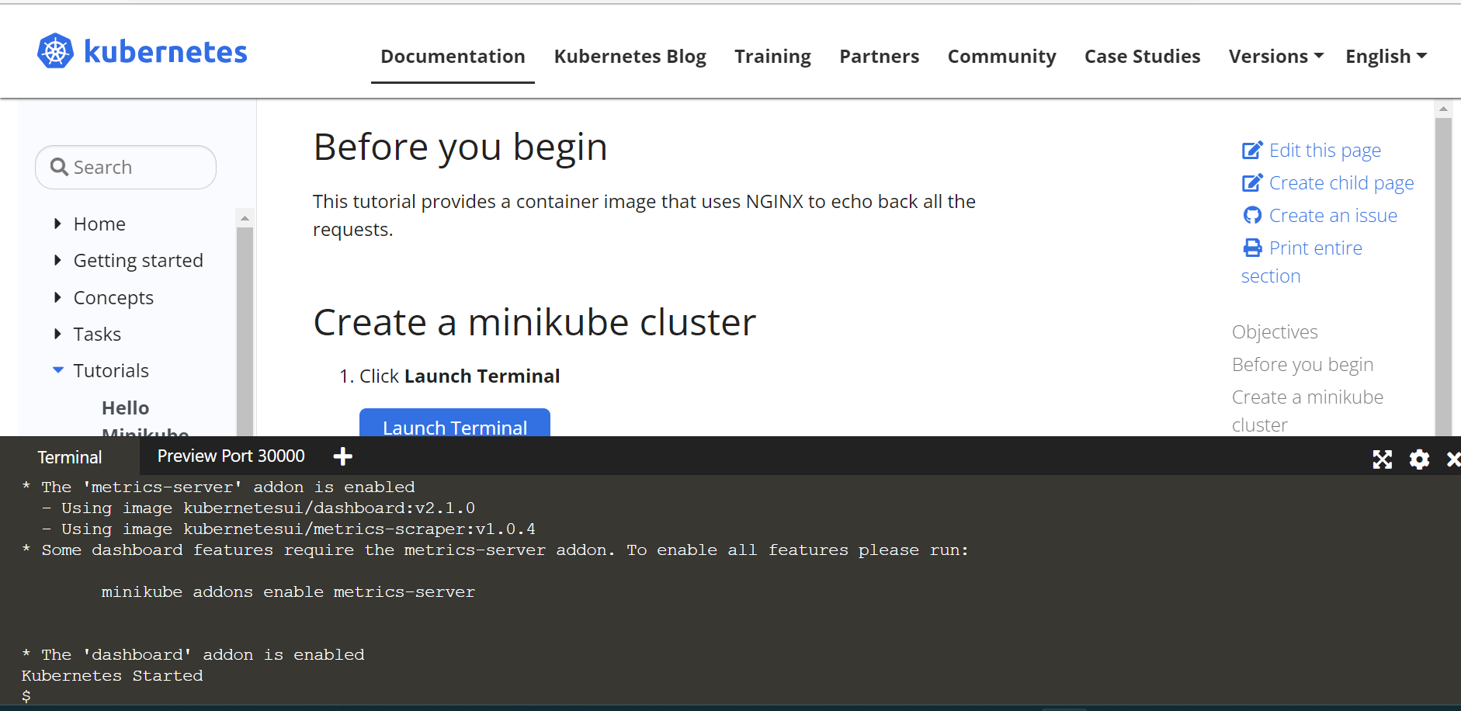

Your Interactive Learning Environment Bash Terminal

$

$ start.sh

Starting Kubernetes...minikube version: v1.18.0

commit: ec61815d60f66a6e4f6353030a40b12362557caa-dirty

* minikube v1.18.0 on Ubuntu 18.04 (amd64)

* Using the none driver based on existing profile

X The requested memory allocation of 2200MiB does not leave room for system overhead (total system memory: 2460MiB). You may face stability issues.

* Suggestion: Start minikube with less memory allocated: 'minikube start --memory=2200mb'

* Starting control plane node minikube in cluster minikube

* Running on localhost (CPUs=2, Memory=2460MB, Disk=194868MB) ...

* OS release is Ubuntu 18.04.5 LTS

* Preparing Kubernetes v1.20.2 on Docker 19.03.13 ...

- kubelet.resolv-conf=/run/systemd/resolve/resolv.conf

- Generating certificates and keys ...

- Booting up control plane ...-

/

/

\

/

|

\

- Configuring RBAC rules ...

* Configuring local host environment ...

* Verifying Kubernetes components...

- Using image gcr.io/k8s-minikube/storage-provisioner:v4

* Enabled addons: storage-provisioner, default-storageclass

* Done! kubectl is now configured to use "minikube" cluster and "default" namespace by default

- Using image k8s.gcr.io/metrics-server-amd64:v0.2.1

* The 'metrics-server' addon is enabled

- Using image kubernetesui/dashboard:v2.1.0

- Using image kubernetesui/metrics-scraper:v1.0.4

* Some dashboard features require the metrics-server addon. To enable all features please run:

minikube addons enable metrics-server

* The 'dashboard' addon is enabled

Kubernetes Started

$

$ minikube start

* minikube v1.18.0 on Ubuntu 18.04 (amd64)

* Using the none driver based on existing profile

X The requested memory allocation of 2200MiB does not leave room for system overhead (total system memory: 2460MiB). You may face stability issues.

* Suggestion: Start minikube with less memory allocated: 'minikube start --memory=2200mb'

* Starting control plane node minikube in cluster minikube

* Updating the running none "minikube" bare metal machine ...

* OS release is Ubuntu 18.04.5 LTS

* Preparing Kubernetes v1.20.2 on Docker 19.03.13 ...

- kubelet.resolv-conf=/run/systemd/resolve/resolv.conf

* Configuring local host environment ...

* Verifying Kubernetes components...

- Using image gcr.io/k8s-minikube/storage-provisioner:v4

- Using image kubernetesui/dashboard:v2.1.0

- Using image kubernetesui/metrics-scraper:v1.0.4

- Using image k8s.gcr.io/metrics-server-amd64:v0.2.1

* Enabled addons: storage-provisioner, dashboard, default-storageclass, metrics-server

* Done! kubectl is now configured to use "minikube" cluster and "default" namespace by default

$

$ minikube dashboard

* Verifying dashboard health ...

* Launching proxy ...

* Verifying proxy health ...

<http://127.0.0.1:34725/api/v1/namespaces/kubernetes-dashboard/services/http:kubernetes-dashboard:/proxy/>

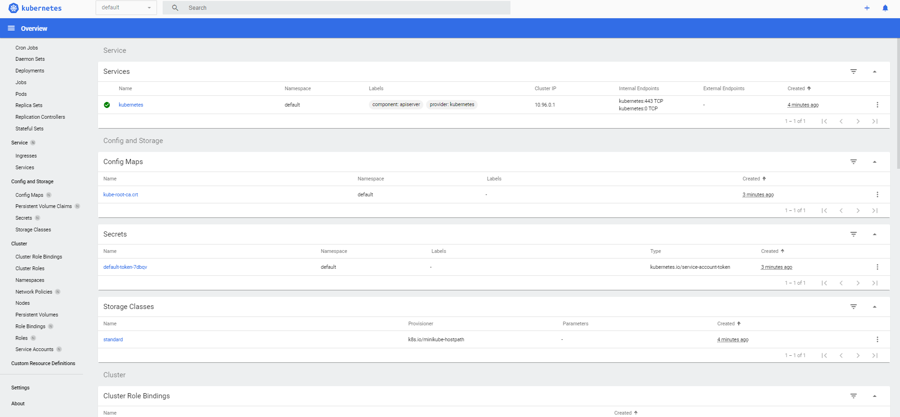

Create node

$ kubectl create deployment m4-assignment-node --image=registry.k8s.io/e2e-test-images/agnhost:2.39 -- /agnhost netexec --http-port=8080

deployment.apps/m4-assignment-node created

commands

$ kubectl get ns

NAME STATUS AGE

default Active 7m15s

kube-node-lease Active 7m16s

kube-public Active 7m16s

kube-system Active 7m16s

kubernetes-dashboard Active 7m10s

$

$ kubectl get pods

NAME READY STATUS RESTARTS AGE

m4-assignment-node-8669c75cc6-gscs7 1/1 Running 0 3m43s

$ kubectl logs m4-assignment-node-8669c75cc6-gscs7

I1230 05:42:19.027330 1 log.go:195] Started HTTP server on port 8080

I1230 05:42:19.028432 1 log.go:195] Started UDP server on port 8081

$

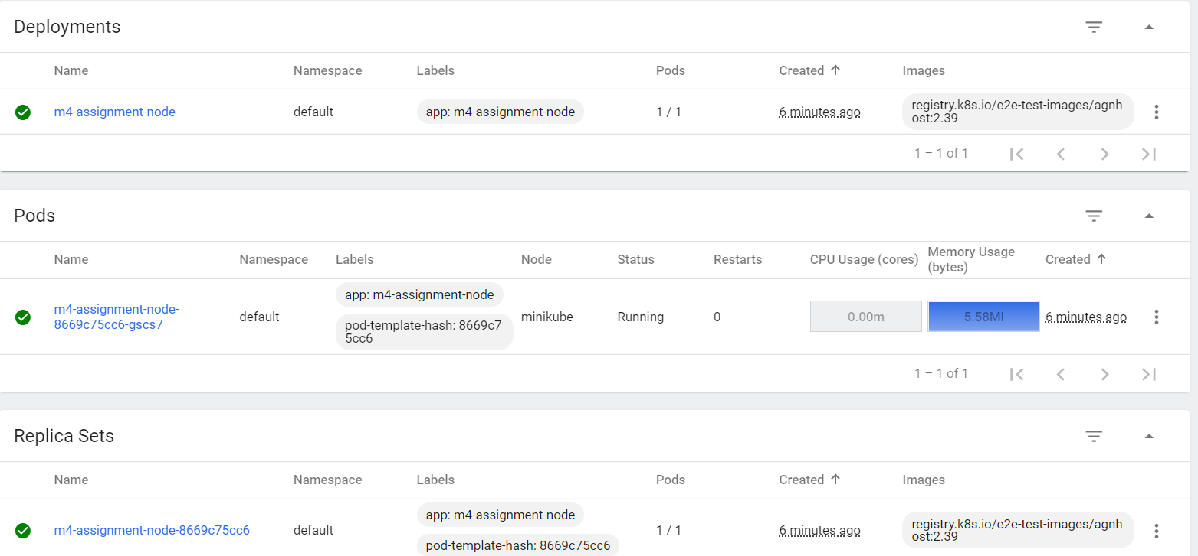

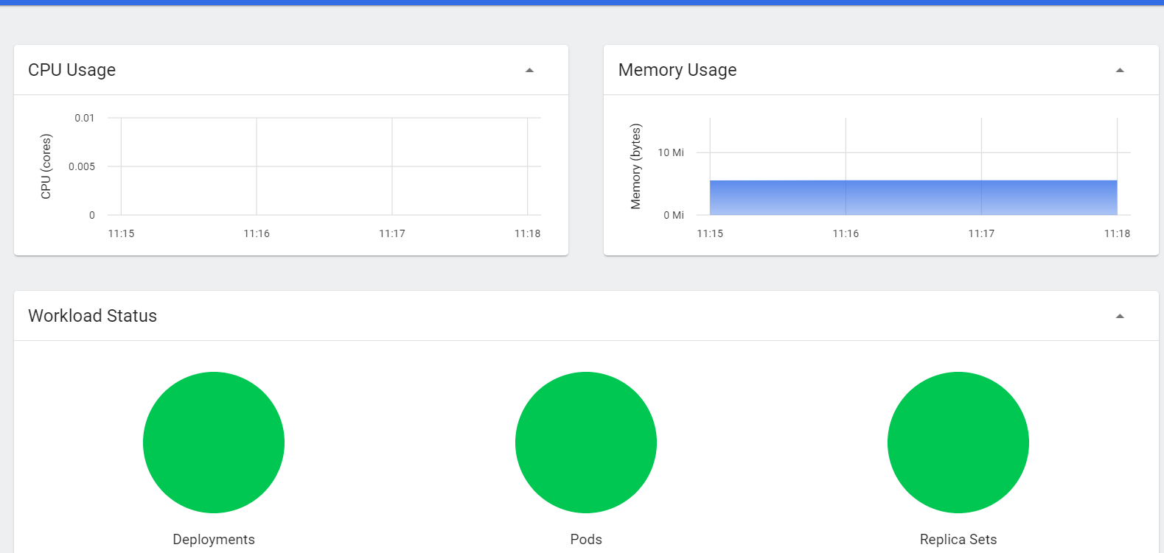

$ kubectl describe pods

Name: m4-assignment-node-8669c75cc6-gscs7

Namespace: default

Priority: 0

Node: minikube/10.0.0.6

Start Time: Fri, 30 Dec 2022 05:42:13 +0000

Labels: app=m4-assignment-node

pod-template-hash=8669c75cc6

Annotations: <none>

Status: Running

IP: 172.18.0.6

IPs:

IP: 172.18.0.6

Controlled By: ReplicaSet/m4-assignment-node-8669c75cc6

Containers:

agnhost:

Container ID: docker://f4c1d786cd449e00ae90fa1a582130a6d72702901137bffdae0cd9d585a002ac

Image: registry.k8s.io/e2e-test-images/agnhost:2.39

Image ID: docker-pullable://registry.k8s.io/e2e-test-images/agnhost@sha256:7e8bdd271312fd25fc5ff5a8f04727be84044eb3d7d8d03611972a6752e2e11e

Port: <none>

Host Port: <none>

Command:

/agnhost

netexec

--http-port=8080

State: Running

Started: Fri, 30 Dec 2022 05:42:19 +0000

Ready: True

Restart Count: 0

Environment: <none>

Mounts:

/var/run/secrets/kubernetes.io/serviceaccount from default-token-7dbqv (ro)

Conditions:

Type Status

Initialized True

Ready True

ContainersReady True

PodScheduled True

Volumes:

default-token-7dbqv:

Type: Secret (a volume populated by a Secret)

SecretName: default-token-7dbqv

Optional: false

QoS Class: BestEffort

Node-Selectors: <none>

Tolerations: node.kubernetes.io/not-ready:NoExecute op=Exists for 300s

node.kubernetes.io/unreachable:NoExecute op=Exists for 300s

Events:

Type Reason Age From Message

---- ------ ---- ---- -------

Normal Scheduled 8m7s default-scheduler Successfully assigned default/m4-assignment-node-8669c75cc6-gscs7 to minikube

Normal Pulling 8m6s kubelet Pulling image "registry.k8s.io/e2e-test-images/agnhost:2.39"

Normal Pulled 8m2s kubelet Successfully pulled image "registry.k8s.io/e2e-test-images/agnhost:2.39" in 3.733522757s

Normal Created 8m2s kubelet Created container agnhost

Normal Started 8m1s kubelet Started container agnhost

$ kubectl get events

LAST SEEN TYPE REASON OBJECT MESSAGE

4m1s Normal Scheduled pod/m4-assignment-node-8669c75cc6-gscs7 Successfully assigned default/m4-assignment-node-8669c75cc6-gscs7 to minikube

4m Normal Pulling pod/m4-assignment-node-8669c75cc6-gscs7 Pulling image "registry.k8s.io/e2e-test-images/agnhost:2.39"

3m56s Normal Pulled pod/m4-assignment-node-8669c75cc6-gscs7 Successfully pulled image "registry.k8s.io/e2e-test-images/agnhost:2.39" in 3.733522757s

3m56s Normal Created pod/m4-assignment-node-8669c75cc6-gscs7 Created container agnhost

3m55s Normal Started pod/m4-assignment-node-8669c75cc6-gscs7 Started container agnhost

4m1s Normal SuccessfulCreate replicaset/m4-assignment-node-8669c75cc6 Created pod: m4-assignment-node-8669c75cc6-gscs7

4m1s Normal ScalingReplicaSet deployment/m4-assignment-node Scaled up replica set m4-assignment-node-8669c75cc6 to 1

9m49s Normal Starting node/minikube Starting kubelet.

9m48s Normal NodeHasSufficientMemory node/minikube Node minikube status is now: NodeHasSufficientMemory

9m48s Normal NodeHasNoDiskPressure node/minikube Node minikube status is now: NodeHasNoDiskPressure

9m48s Normal NodeHasSufficientPID node/minikube Node minikube status is now: NodeHasSufficientPID

9m49s Normal NodeAllocatableEnforced node/minikube Updated Node Allocatable limit across pods

9m33s Normal Starting node/minikube Starting kubelet.

9m33s Normal NodeHasSufficientMemory node/minikube Node minikube status is now: NodeHasSufficientMemory

9m33s Normal NodeHasNoDiskPressure node/minikube Node minikube status is now: NodeHasNoDiskPressure

9m33s Normal NodeHasSufficientPID node/minikube Node minikube status is now: NodeHasSufficientPID

9m33s Normal NodeNotReady node/minikube Node minikube status is now: NodeNotReady

9m33s Normal NodeAllocatableEnforced node/minikube Updated Node Allocatable limit across pods

9m24s Normal RegisteredNode node/minikube Node minikube event: Registered Node minikube in Controller

9m24s Normal NodeReady node/minikube Node minikube status is now: NodeReady

9m22s Normal Starting node/minikube Starting kube-proxy.

$

$

$ kubectl get nodes

NAME STATUS ROLES AGE VERSION

minikube Ready control-plane,master 16m v1.20.2

$

$ kubectl get events

LAST SEEN TYPE REASON OBJECT MESSAGE

12m Normal Scheduled pod/m4-assignment-node-8669c75cc6-gscs7 Successfully assigned default/m4-assignment-node-8669c75cc6-gscs7 to minikube

12m Normal Pulling pod/m4-assignment-node-8669c75cc6-gscs7 Pulling image "registry.k8s.io/e2e-test-images/agnhost:2.39"

12m Normal Pulled pod/m4-assignment-node-8669c75cc6-gscs7 Successfully pulled image "registry.k8s.io/e2e-test-images/agnhost:2.39" in 3.733522757s

12m Normal Created pod/m4-assignment-node-8669c75cc6-gscs7 Created container agnhost

12m Normal Started pod/m4-assignment-node-8669c75cc6-gscs7 Started container agnhost

12m Normal SuccessfulCreate replicaset/m4-assignment-node-8669c75cc6 Created pod: m4-assignment-node-8669c75cc6-gscs7

12m Normal ScalingReplicaSet deployment/m4-assignment-node Scaled up replica set m4-assignment-node-8669c75cc6 to 1

17m Normal Starting node/minikube Starting kubelet.

17m Normal NodeHasSufficientMemory node/minikube Node minikube status is now: NodeHasSufficientMemory

17m Normal NodeHasNoDiskPressure node/minikube Node minikube status is now: NodeHasNoDiskPressure

17m Normal NodeHasSufficientPID node/minikube Node minikube status is now: NodeHasSufficientPID

17m Normal NodeAllocatableEnforced node/minikube Updated Node Allocatable limit across pods

17m Normal Starting node/minikube Starting kubelet.

17m Normal NodeHasSufficientMemory node/minikube Node minikube status is now: NodeHasSufficientMemory

17m Normal NodeHasNoDiskPressure node/minikube Node minikube status is now: NodeHasNoDiskPressure

17m Normal NodeHasSufficientPID node/minikube Node minikube status is now: NodeHasSufficientPID

17m Normal NodeNotReady node/minikube Node minikube status is now: NodeNotReady

17m Normal NodeAllocatableEnforced node/minikube Updated Node Allocatable limit across pods

17m Normal RegisteredNode node/minikube Node minikube event: Registered Node minikube in Controller

17m Normal NodeReady node/minikube Node minikube status is now: NodeReady

17m Normal Starting node/minikube Starting kube-proxy.

$ kubectl config view

apiVersion: v1

clusters:

- cluster:

certificate-authority: /root/.minikube/ca.crt

extensions:

- extension:

last-update: Fri, 30 Dec 2022 05:38:31 UTC

provider: minikube.sigs.k8s.io

version: v1.18.0

name: cluster_info

server: https://10.0.0.6:8443

name: minikube

contexts:

- context:

cluster: minikube

extensions:

- extension:

last-update: Fri, 30 Dec 2022 05:38:31 UTC

provider: minikube.sigs.k8s.io

version: v1.18.0

name: context_info

namespace: default

user: minikube

name: minikube

current-context: minikube

kind: Config

preferences: {}

users:

- name: minikube

user:

client-certificate: /root/.minikube/profiles/minikube/client.crt

client-key: /root/.minikube/profiles/minikube/client.key

$

$ kubectl get services

NAME TYPE CLUSTER-IP EXTERNAL-IP PORT(S) AGE

kubernetes ClusterIP 10.96.0.1 <none> 443/TCP 20m

$ kubectl expose deployment m4-assignment-node --type=LoadBalancer --port=8080

Service/ m4-assignment-node exposed

kubectl get services

NAME TYPE CLUSTER-IP EXTERNAL-IP PORT(S) AGE

kubernetes ClusterIP 10.96.0.1 <none> 443/TCP 23m

m4-assignment-node LoadBalancer 10.100.22.149 <pending> 8080:30384/TCP 110s

$

$ minikube service m4-assignment-node

|-----------|--------------------|-------------|-----------------------|

| NAMESPACE | NAME | TARGET PORT | URL |

|-----------|--------------------|-------------|-----------------------|

| default | m4-assignment-node | 8080 | http://10.0.0.6:30384 |

|-----------|--------------------|-------------|-----------------------|

* Opening service default/m4-assignment-node in default browser...

Minikube Dashboard is not supported via the interactive terminal experience.

Please click the 'Preview Port 30000' link above to access the dashboard.

This will now exit. Please continue with the rest of the tutorial.

X Exiting due to HOST_BROWSER: exit status 1

*

* If the above advice does not help, please let us know:

- https://github.com/kubernetes/minikube/issues/new/choose

